**HIVE DOCUMENTATION**

1. To create a database

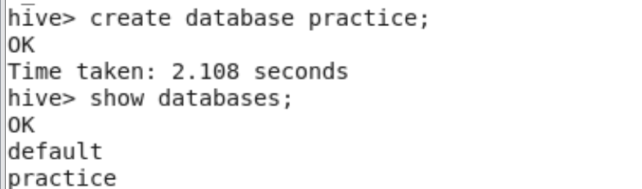

2.To create a table 

3.To get the the description of the table use describe command

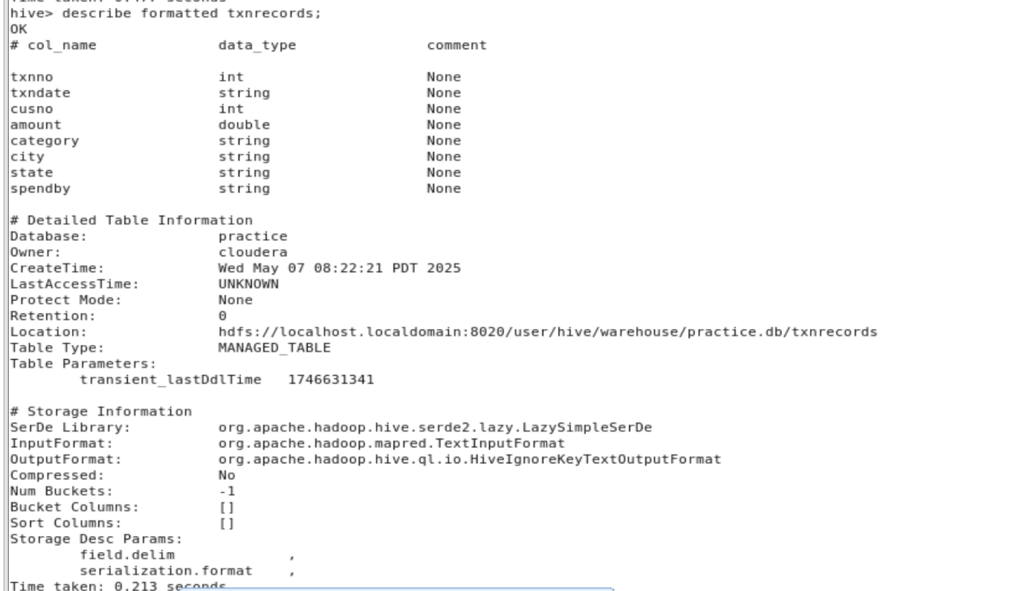

4. Finding number of records of a table

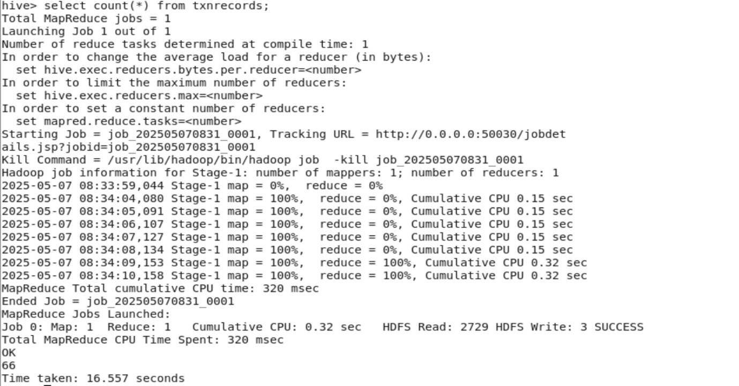

**Copy from one table to another**

1.create first table



2.Load data to first table

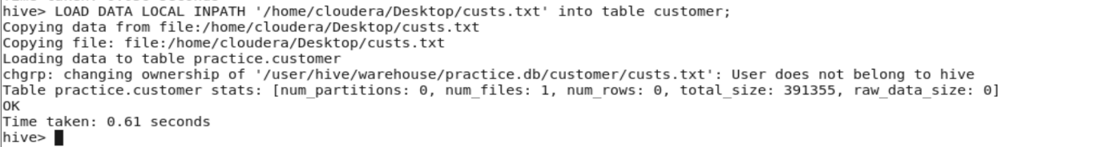

3.Create destination table



4. Copy the data from one table to another table using below command

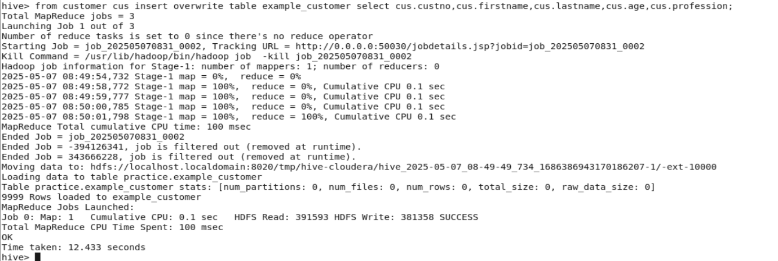

**PARTITIONING**

1.Create a table



2.Load the data from a file to table

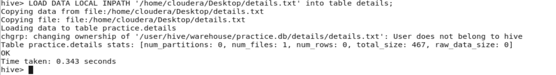

3.Create a partitioned table using below command



4. create a partition using the below commands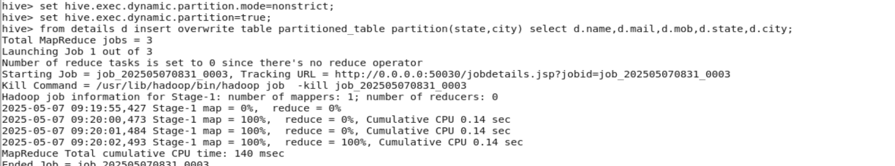

**RESULTS**

